Date: 14.03.2025
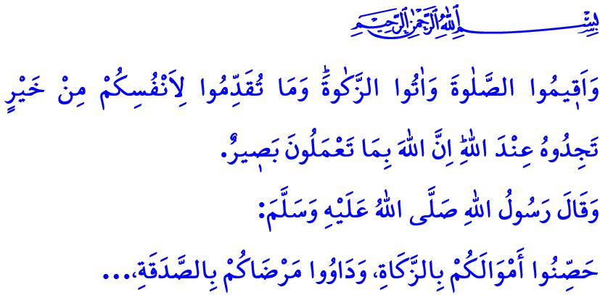A BRIDGE OF GOODNESS: ZAKAT AND SADAQAH AL-FITR
Honorable Muslims!
Our sublime religion, Islam, commands us to share our wealth with those in need and to support and care for them. It commands us to remain united with a strong sense of solidarity and mutual support. Zakat is one of the acts of worship that instill in us such sense of awareness. Our Lord Almighty (swt) states, “Establish prayer, and pay alms-tax. Whatever good you send forth for yourselves, you will ˹certainly˺ find ˹its reward˺ with Allah. Surely Allah is All-Seeing of what you do.”
Dear Believers!
Zakat, one of the five pillars of Islam, is the obligatory act of giving a specific portion of a Muslim’s wealth, if they meet the threshold of wealth, to those in need, once a year. Zakat is an act of worship that embodies sharing, solidarity, and mutual support. Through zakat, people connect with one another, fostering an atmosphere of peace built on love and respect. Bridges of kindness and compassion are formed between the rich and the poor. Zakat serves as a reminder that Allah is the true owner of all wealth and possessions. It plays a vital role in increasing goodness and reducing evil. It safeguards us from stinginess and excessive attachment to worldly possessions. It purifies our body, soul, and wealth from both material and spiritual impurities.In this regard, the Messenger of Allah (saw) says, ““Protect your wealth by giving zakat, and seek healing for your sick by giving charity.”
Esteemed Muslims!
Another act of worship that reinforces our awareness of sharing and solidarity is sadaqah al-fitr. This act of worship, known as fitrah, is an expression of gratitude for observing Ramadan and reaching eid. Every Muslim who meets the religious criteria of wealth is responsible for giving fitrah on behalf of themselves and their dependents to those in need.Fitrah can be given before eid, and doing so is even more virtuous. Because fitrah enables our brothers and sisters in need to share in the joy of eid.
Dear Believers!
Our Almighty Lord states, وَف۪ٓي اَمْوَالِهِمْ حَقٌّ لِلسَّٓائِلِ وَالْمَحْرُومِ “And in their wealth there was a rightful share ˹fulfilled˺ for the beggar and the poor.” In Islam, giving zakat is not merely a matter of personal choice or generosity. Therefore, a Muslim should give zakat to those in need with sincerity and kindness, without causing harm or hurt to their dignity.
According to Islam, zakat and fitrah can be given either in cash or in kind. Giving in cash is the principle. However, if given in kind, it must consist of good-quality, clean food, drink, or clothing that will genuinely benefit those in need. Our Almighty Lord emphasizes this matter, stating: “Do not pick out worthless things for donation, which you yourselves would only accept with closed eyes.” Additionally, one should refrain from distributing or facilitating the distribution of products from those who oppress the innocent in Gaza and those who support them as zakat or charity.
In Islam, zakat and sadaqah are based on the principle of direct possession, meaning they must reach the hands of the poor. In this regard, we should begin by giving our zakat and sadaqah to our needy relatives and neighbors, while also considering the impoverished in our villages, districts, and cities. However, those who are unable to give zakat and fitrah locally, or who wish to assist those in need both domestically and internationally, may distribute their zakat and fitrah through a trusted proxy. However, in such cases, they must ensure that their zakat and sadaqah reach their rightful recipients.
Dear Muslims!
As we celebrate the 50th establishment anniversary of our Türkiye Diyanet Foundation, we recognize it as one of the most significant charitable movements of the past century. Starting this year, the period from March 13 to 20 will be observed annually as “Benevolence Week.” I pray to Allah the Almighty that this week serves as a means for goodness to prevail on earth. Like other charitable organizations that operate with a sense of worship and trust, our Türkiye Diyanet Foundation serves those who wish to give their zakat and sadaqah by proxy. This year, too, under the motto “May Our Brotherhood Be Blessed with Zakat”, inshallah, we will deliver the zakat and sadaqah entrusted to us by our generous nation to our brothers and sisters in need, ensuring accountability and transparency. You can also take part in this movement of goodness by contributing through our religious officials, provincial and district mufti offices, or via our Foundation’s official website.
Dear Believers!

Next Tuesday, inshallah, we will once again commemorate the anniversary of the Çanakkale Victory. Çanakkale stands as one of the greatest symbols of our heroic ancestors’ unwavering commitment to the struggle for religion, state, homeland, and nation, proving that they would never abandon the fight for freedom and independence. Our duty is to keep the spirit of this glorious struggle alive and pass it on to future generations. On this occasion, I pray for our Lord Almighty’s mercy upon all our martyrs, especially those of Çanakkale, as well as our veterans who have passed on to the eternal realm. May Allah the Almighty let our state last forever and grant our nation enduring happiness.

Baqarah, 2/110.
Tabarani, Mu’jam al-Kabir, XIX, 128.
Dhariyat, 51/19.
Baqarah, 2/267. General Directorate of Religious Services

